Elizabeth Hawkins

CIS-Linux Administration

Awk assignment

October 3, 2021

1. Print all the first names

awk ‘{print $1}’ AwkLab.data is the command I used to prints all first names. {print $1} prints the first word of the line.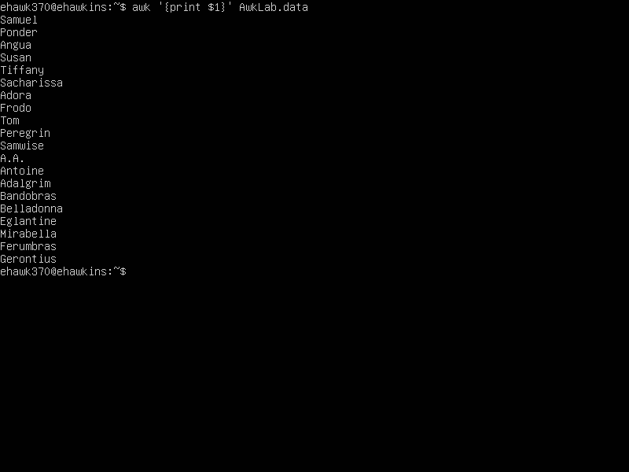

1. Print phone numbers for Tom and Frodo
2. Print Peregrin’s name and phone number area code.

awk -F: ‘/Peregrin/{print $1,$2}’ AwkLab.data is the command I used to print Peregrin’s name and phone number and area code. with -F we tell the computer to separate data. /Peregrin is the name we are looking for{print $1,$2} tells the computer to print what comes before and after the first separator but only before the second. Text

1. Print all phone numbers in the 408-area code

awk -F: ‘/(408)/ {print $2}’ AwkLab.data is the command I used to print all numbers with a 408-area code.

with -F: we tell the computer to sperate the data by ‘:’ /(408)/ is the area code we are looking for. Using ‘{print $2} we tell the computer to print what occurs after the first separator but before the second which is phone numbers.

1. Print all last names beginning with either a B or D

awk -F”[ :]” ‘$2 ~/^(B|D)/{print $2}’ AwkLab.data is the command I used to print all last names beginning with B or D. Awk -F[ :] is the field separator $2 ~ is the last field /^(B|D)/ is the last names you are looking for to print {print $2} is to print the second field. Text

1. Print all first names containing four or less characters

Awk ‘$1~ /^[A-Za-z]{,4}$/{print $1}’ AwkLab.data is the command I used to print names containing four letters or less. $1~ looks at the first field in each line /^[A-Za-z{,4}$/ looks in the first field for every word that starts and ends with four characters or less. {print $1} prints the first field in the line.



1. Print the first names of all those in the 916-area code

awk ‘$3 ~ /(916)/{print $1}’ FS=’[: ]’ AwkLab.data is the command I used to print the first names of all those in the 916-area code. Awk $3~ represents the third field, (916) is the area code you are looking for,{print $1} prints the first word of the line, FS=[: ] is any single character or regular expression which you want to use as a input field seperator so it seperates the first name from everything and just prints the first names.

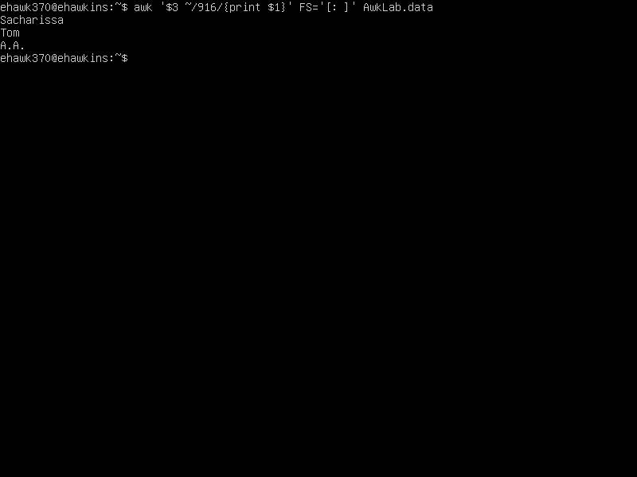

1. Print Sacharissa’s campaign contributions. Each value should be printed with a leading dollar sign: e.g, $250 $100 $175

awk ‘$1 ~ /Sacharissa/{print “$”$5,”$”$6,”$”$7}’ FS=’[: ]’ AwkLab.data is the command I used to print Sacharissa’s campaign contribution.

awk $1 is the first field /Sacharissa/ is the name you are looking for {print“$”$5,”$”$6,”$”$7} is what’s in the 5th,6th, and 7th fields each filed having a dollar sign printed with each field. FS= [: ] is any single character or regular expression which you want to use as a input field seperator so it seperates the values from everything else.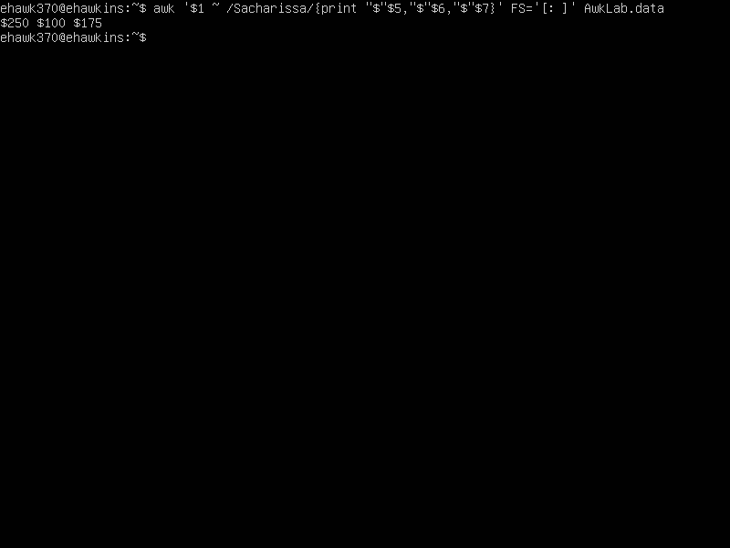

1. Print last names followed by a comma and the phone number. Be careful of the last name’s format.

awk -F”[ :]” {print $2 “,” $3,$4}’ AwkLab.data is the command I used to print last names followed by a comma and the phone number. awk -F”[ :]” we tell the computer to separate data. {print $2 prints the second field, “,” means to have it be followed by a comma, $3,$4 fields prints the numbers.